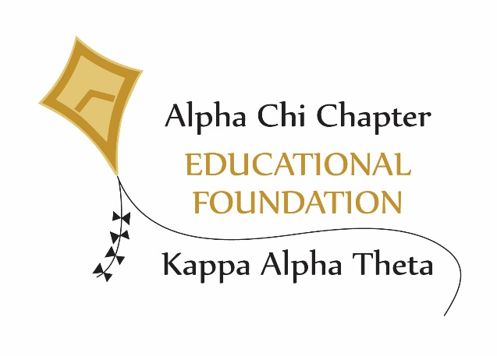
Annual Report
2023

The Alpha Chi Chapter of Kappa Alpha Theta Educational Foundation, Inc. was incorporated by the state of Indiana Sept. 10, 2012, and received its 501 (c)(3) status as a tax-exempt non-profit organization on April 6, 2014. Membership is defined as all Thetas initiated or affiliated with Alpha Chi Chapter.

Mission:
The Alpha Chi Educational Foundation was founded with the following mission:
- To provide funds for scholarship and awards for members of the active chapter, recognizing scholarship, leadership, and service.
- To be a future resource for projects in the chapter house that fit the educational use requirements of the Educational Foundation.
- To support the Century of Sisterhood campaign to secure funds to pay down the mortgage and renovate the first floor of chapter house. This has been accomplished.

Trustees:
Marilynn Bottomley Dammon ‘66 – President
Marcia Erickson Weber ‘63- Vice President
Ann Marie Kehlor ’83 – Secretary
Abby Hanley ‘14 – Treasurer
Jane Baur Merrill ‘61
Linda Markins Sorensen ‘60
Lorna Gless Utley ‘73
Sarah Arthur Murphy ‘04
Jennifer Linstroth Mingo ‘93
Sydney Hummel ‘20– Non-voting member from chapter

This year, Jane Baur Merrill ’61 and Lorna Gless Utley ’73 retired from the board, and Peggy Fawcett Edwards ’69 and Anne Sorensen Inman ’87 were elected as new members of the board.

Supporting Details:

During the year, the Educational Foundation received contributions for unrestricted use, for the awarding of annual scholarships, for improving educational space, and for the Scholarship endowments.
As of 9/27/23, cash assets for the Educational Foundation were:

Regions Bank Funds $ 41,862.79
Morgan Stanley Funds $537,565.91
__________

Total Assets $579,428.70

Donations to the Educational Foundation are often made as direct gifts and sometimes in memory of deceased sisters by those who want to support the awarding of scholarships and upgrading the educational portions of the chapter house. We gave a total of 20 $1,000 scholarships and 2 $100 awards during the 2022-2023 school year and have received $77,032.33 in donations YTD.

Scholarships and Awards:
Named scholarship endowments have been established by:
Susan Dalenberg Kessler ’60
Robert Griffiths, in memory of Connie Corson Griffiths ’60
Family Members, in memory of June Bode Dorman ’51
Alpha Chi Educational Foundation, in honor of Mary Lincoln Campbell ’64
Julia Kirkpatrick McKinney ’51, in honor of the McKinney Family
AX Sisters and friends, in memory of Katie Dittrich Wood McMillin ’48 and
Carol Wood Gorenflo ’73
Class of ’64 – The Dappers
The Campbell Foundation, in honor of Mary Lincoln Campbell ’64
Mary Ellen Binney Totten-Lovell ’50
Class of ’04 in memory of Kelley Hudson ‘04
Marilynn Bottomley Dammon ’66
Joe Trimmer, in memory of Carol Straley Trimmer ’62
Robert and Linda M. Sorensen ’60
Ann Fawcett Murphy ‘72 and Peggy Fawcett Edwards ’69 - The Snyder Family Fund
AX Sisters and Family of Lindy Baugh ’70
Anne Sorensen Inman ’87 and Linda Markins Sorensen ’60
Robert F. Benbow, in memory of Crystal Ruskin Benbow ‘58
Jackie Maynard Bayer ‘65
Nancy Bange Kennedy ‘69

The first four Educational Foundation Scholarships were awarded during the Centennial celebration in 2015. To date, 99 scholarships totaling $92,000 have been awarded to college members who excel in scholarship, leadership, and service to fraternity and community. Financial need is also considered for some of the scholarships.

Recipients of the $1,000 scholarship grants in 2023 were:

Alisha Benbow ’20 - In memory of Crystal Ruskin Benbow ’58 by Theta sisters and Bob Benbow
Anna Black ‘21 – Contributions from Amazon Smile
Kara Burks ‘21 – In memory of Kelley Hudson by Class of ‘04
Ellen Densmore ‘21 -- In memory of Mary Ellen Binney Totten Lovell ’50
Charlene Fibbe ‘21 – In honor of the AX Chapter and its support of the Educational Foundation
Maura Flood ’21 – In memory of Bob Sorensen by Theta sisters of Linda Markins Sorensen ‘60
Jentrie Gearhart ’21 – In memory of Margaret Bowman Ricks ’59 by Ted Ricks
Paige Hackleman ‘22– In memory of Jim Dammon by Theta sisters of Marilynn Bottomley Dammon ‘66
Sydney Haines ‘20 – In honor of Bonnie Rabe Vinovich ’59 by the John W. Anderson Foundation
Lauren Hartwell ‘21—In memory of Lindy Baugh’70 by Theta sisters, family, and Katie Baugh Nielsen ‘69
Sydney Hummel ‘20 – In memory of Connie Corson Griffiths ’60 by Bob Griffiths
Martha Hunter ‘20 – Susan Dalenberg Kessler ’60 Endowed Scholarship
Avery Kimmel ‘21 – In memory of June Bode Dorman ’51 by her family
Leah Limber ‘22 – In memory of Pam Habicht Rudy ’64 by The Dappers, Class of ‘64
Hana Mahmoud ‘22– In memory of Carolyn Norman Hibbeln ’59 by her Theta sisters
Victoria Patellos ‘20– In memory of Carol Straley Trimmer ’62 by Class of ’62 and Joe Trimmer
Meredith Pobanz ‘21 – In honor of the McKinney Family by Judy Kirkpatrick McKinney ’51
Katherine Rushka ‘20 – In memory of the Snyder Family by Ann Fawcett Murphy ’72
Sydney Sorensen ‘20– Mary Lincoln Campbell ’64 Endowed Scholarship
Anna Trieloff ‘20– In memory of Katie Wood McMillin ’48 and Carole Wood Gorenflo’73

In 2017, the Educational Foundation began recognizing the college member with the most improved GPA each semester. This award, created to honor and remember Zoe Coulson, is called the Zoe Coulson Scholar Award. To date, thirteen awards have been made. Receiving the $100 checks and certificates this past year were:
Elena Krizman ‘20 – Fall Semester, 2022
Chloe Cafferty ’22 -- Spring Semester, 2023

In recognition of the Chapter’s fourth consecutive semester with the highest ranking in Panhellenic , the Educational Foundation treated all of the members to a dinner of Jimmy Johns sandwiches during the fall and spring semesters. Congratulations to the chapter on continuing excellent scholarship.

Improvements in Facility for Educational needs:
Enhancing the womens’ educational experience in the chapter house is an important part of the Educational Foundation’s mission. During the summer of 2023, outlet ports were installed under the tables in the library to increase conductivity there. This fall, an old leaky printer was replaced with a technology-advanced model.

Funding:
The Educational Foundation has created procedures for accepting and awarding scholarship grants, as well as policies and procedures for accepting gifts, investments, and spending for its long-term assets. In 2015 an annual Second Century Club was initiated for all annual donations of $500 or more. Names are listed annually in the spring issue of the Theta Kite Newsletter.

We are grateful to the many alums, friends, family members, Alpha Chi Chapter, and the John W. Anderson Foundation for their loyal support.

Campaigns to attract donations are conducted annually, near the end of the year. A special appeal was made in 2018 and 2019 to suggest alumnae include the Educational Foundation in their planned giving. Nineteen named scholarship endowment funds have been established and are generating funds for scholarships.

The Alpha Chi Chapter Educational Foundation is dependent on the generosity of Alpha Chi Thetas for its continued success in awarding scholarships and funding further educational improvements for the chapter house. Any and all gifts are appreciated and members are encouraged to consider planned giving and long term gifts. There is opportunity for “named” endowments and/or scholarship awards. Donations can be made by check, credit card, or online. Gifts are tax deductible. For more information please contact Marilynn Dammon, Marilynndammon@gmail.com, 765-426-4403, Linda M. Sorensen, sorensenwl@comcast.net 765-714-1845 or any of the other Foundation Trustees.

Marilynn Dammon, President
11.28.2023

